Design Plan for FemHora Website

FemHora is a versatile and innovative watch company that offers a wide range of timepieces designed to suit every lifestyle and occasion. The website will serve as a hub for watch enthusiasts looking for everything from luxury accessories to practical and timeless pieces. Here is the planned structure for the website.

The Website

Purpose

FemHora is watch company that offers a wide range of watches designed for your lifestyle or occasion. The website for FemHora will serve as a hub for watch enthusiasts looking for:

***Luxury & Fancy*** Watches: Sleek and elegant designs for those special moments, crafted with the finest materials and precision.

***Sport Watches***: Durable and high-performance timepieces built to withstand active lifestyles and rigorous outdoor adventures.

***Casual Watches***: Stylish yet understated options for everyday wear, combining comfort and fashion effortlessly.

***Modern Watches***: Cutting-edge designs with contemporary aesthetics, perfect for trendsetters who value the latest in watch fashion.

***Classic & Vintage Watches***: Timeless pieces inspired by the elegance of the past, blending traditional craftsmanship with modern functionality.

The website will allow customers browse all sorts of watches that have their unique look and story.

Target audience

The target audience for FemHora is watch enthusiasts who likes ***Luxury & Fancy*** Watches, ***Sport Watches, Casual Watches, Modern Watches*** or/and ***Classic & Vintage Watches.***

# Home Page(PAGE)

This will be an elegant introduction to FemHora, featuring high-quality images of the various watch collections, from fancy to casual, with a spotlight on the latest releases. The home page will set the tone for the brand’s diverse offerings while conveying a luxurious yet approachable vibe.

# About Us(PAGE)

This section will tell the story of FemHora, from its origins to its mission of creating watches for every occasion. It will highlight the company's commitment to precision, craftsmanship, and innovation, making it stand out in the watch industry.

# Collections(PAGE)

The heart of the website, the 'Collections' page, will categorize the watches into different styles: Fancy, Sport, Casual, Modern, and Old-Class. Each collection will have detailed descriptions, high-quality images, and filters for easy browsing.

# Contact/Support(PAGE)

A dedicated page where customers can reach out for any questions, warranty information, or customer support.

### Logo

The logo for FemHora Tours is a simple wave icon, an image obtained from <https://pixabay.com/vectors/waves-logo-company-logo-7857446/> and created by donauwood. This image is free for personal and commercial purposes with attribution.



### Colour Palette

This colour palette was generated using https://coolors.org. The colours are a bright mix of natural colours to appeal to active.

#5C5D67

#CEE5F2

#ACCBE1

### Website Banner

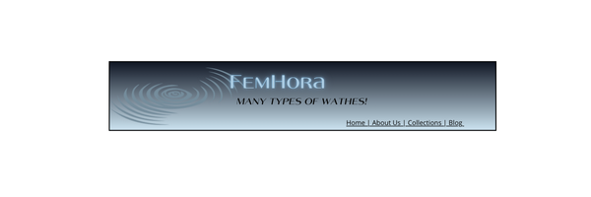

### A diagram of a computer Description automatically generated with medium confidenceMobile Layout

### Desktop Layout

